Project (Roadmap)
Title: Business Intelligence Dashboards for Organizational Performance Analytics in Healthcare
Batch 3
Lahari 2420030055
Harshini 2420030323
Madhuri 2420030292
Manasa 2420030671

Domain : Health care
Dataset
- CDC Diabetes Health Indicators (UCI): (demographic, lifestyle, and health indicator data for diabetes risk prediction)
https://archive.ics.uci.edu/dataset/544/estimation+of+obesity+levels+based+on+eating+habits+and+physical+condition
- Hospital Patient Data Records Dataset (hospital patient demographics, treatment, admission, discharge, and healthcare analytics data)
https://www.kaggle.com/datasets/sathwiknomula/hospital-patient-records-dataset?utm_source=chatgpt.com
- Health care dataset (patient medical, treatment, and healthcare cost data for healthcareanalysis)

https://www.kaggle.com/datasets?search=health
Abstract
This project focuses on applying data visualization, business intelligence, and predictive analytics techniques to benchmark healthcare datasets, including the CDC Diabetes Health Indicators (UCI), Hospital Patient Data Records Dataset (Kaggle), and a benchmark Healthcare Dataset (Kaggle). These datasets contain demographic, lifestyle, clinical, treatment, and healthcare cost information that can be used to analyze patient health, identify disease risk factors, and evaluate healthcare performance. The data is preprocessed to ensure quality and consistency, followed by exploratory data analysis using interactive visualizations such as bar charts, pie charts, line charts, histograms, and dashboards. Descriptive, diagnostic, and predictive analytics are applied to discover patterns, monitor healthcare trends, and predict disease outcomes based on lifestyle and medical factors.
The insights obtained from this project support data-driven decision-making, improve healthcare management, enable early disease prediction, and enhance the overall quality of patient care.

Recommended Research Pipeline
Benchmark Healthcare Datasets
(CDC Diabetes Health Indicators
Hospital Patient Records
Healthcare Dataset)
│
▼
Data Cleaning
• Remove Duplicates
• Handle Missing Values
• Correct Data Types
│
▼
Exploratory Data Analysis (EDA)
• Summary Statistics
• Distribution Analysis
• Correlation Analysis
• Outlier Detection

Data Preprocessing
• Missing Value Imputation
• Encoding (Label/One-Hot)
• Normalization / Standardization
│
▼
Feature Engineering
• BMI Categories
• Age Groups
• Lifestyle Risk Score
• Cost Categories (if applicable)
│
▼
Feature Selection
• Correlation Analysis
• Chi-Square Test
• Feature Importance
│
▼
Train-Test Split
(80:20 or 70:30)

Machine Learning Models
• Logistic Regression
• Decision Tree
• Random Forest
• XGBoost
• CatBoost

Performance Evaluation
• Accuracy
• Precision
• Recall
• F1-Score
• ROC-AUC
• Confusion Matrix

Explainable AI (XAI)
• SHAP
• LIME

Data Visualization
• Bar Charts
• Pie Charts
• Histograms
• Heatmaps
• Boxplots
• Correlation Matrix
• Feature Importance
• Interactive Dashboard

Comparative Analysis
Compare:
• Logistic Regression
• Decision Tree
• Random Forest
• XGBoost
• CatBoost

Metrics:
• Accuracy
• Precision
• Recall
• F1-Score
• ROC-AUC
Research Conclusions
• Best Performing Model
• Important Lifestyle Risk Factors
• Disease Prediction Insights
• Healthcare Recommendations
Architechture
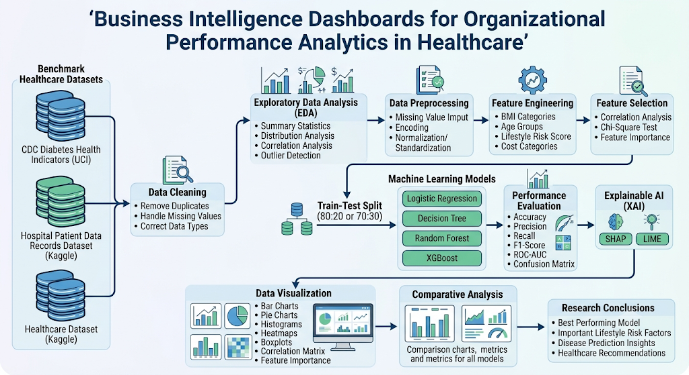

Expected Dashboard

* Total Patients
* Heart Disease Cases
* Age-wise Analysis
* Gender-wise Analysis
* Blood Pressure Analysis
* Cholesterol Analysis
* Chest Pain Analysis
* Heart Disease Distribution
* Risk Factor Analysis
* Feature Importance
* Organizational KPIs
* Performance Trends

